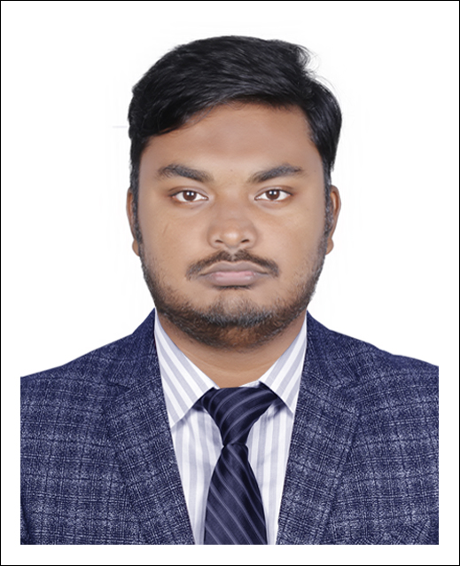
Resume Of

Name: Rabbi, Md. Fazla
Address: Flat No: 1A, House:40, Road: 13, Nikunja-2, Khilkhet, Dhaka.
E-Mail : md.fazlarabbi07@gmail.com
Contact No: +8801644476236, +8801793409201
-------------------------------------------------------------------------------------------------------

Career Statement: Seeking for a Computer Science Engineering and Information Technological (IT) position to apply my academic knowledge, work experience, skills to work on innovative and target oriented projects in the field of Information Technology, SEO and Digital Marketing.

Position Sought: Executive IT.

Work Experience:
- Worked as a Teaching Assistant in American International University.
- Working as IT Specialist at Ahsan Tech IT International Limited.
        - IT support maintenance over.
        - Digital Content Marketing.
        - Search Engine Optimization Technique
        - Ads Marketing (Facebook, Google, LinkedIn, Instagram, Pinterest and so on)
        - Clients Counseling both Offline & Online.

Career Statement:
- Clear Concept about Search Engine Optimization (SEO).
- Clear Concept about Digital Marketing and Content Writing.
- Clear Concept about Backlink strategy.
- Clear Concept about Content Marketing Development.
- Clear concept about Web Development on HTML, Java Script, Ajax, CSS etc.
- Basic concept about Computer Networking & security.
- Experienced in working with Version Controlling tools like GitHub.

Educational Qualifications:

- Bachelor of Science in Computer Science and Engineering (Graduated)
American International University-Bangladesh.
Current CGPA 3.32 out of 4.00

Technical Skills:
- Programming Languages:
C, C++, Java, C#, XML, PHP, JavaScript.

- Database Management Systems:
Oracle (+ PL/SQL), MySQL, Microsoft SQL Server

Certification:
- Cisco Certified (CCNA) at American International University Bangladesh (AIUB).
- Certified as Digital Marketing & SEO specialist from Coder Trust Bangladesh.

Project Experience:

- Developed a Freelancing website named “Tourism Management System” using HTML, CSS, PHP, JavaScript, AJAX (IDE- Visual Code) in 2019-20 spring semester.
- Developed a Desktop based “Apartment Management System” using C# .NET (IDE- Microsoft Visual Studio 2012, Database- MS SQL Server) in 2019-20 Fall semester.
- Developing a GLUT Project on “Smart City-Dhaka” using C++ OpenGL library (IDE- Code Bocks) in Fall 2020-21 semester.
- Developed a Library Management System using Java (IDE- Notepad++) in 2019-20 summer semester.
- Designed an Object-Oriented Analysis on Smart parking system of AIUB (Visual Paradigm 13.2) in Fall 2019-20.

Academic Research:
- Completed An Academic Research name “Issue and challenge of consumer financing and PayPal in Bangladesh”. We are working on find the actual reason for not accessing the International Payment Gateway-PayPal.
- Another Publication is running “Factors that resist Google Ranking.”

Personal Details:
Father Name: Late Alauddin Khan
Mother Name: Rashida Begum
Nationality: Bangladeshi
Date of Birth: 07-07-1996
Religion: Islam
Language known: Bangla, English, Hindi
Marital Status: Unmarried.

Reference:

Dr. Dip Nandi
Assistant Professor and Director
(Undergraduate Program)
Department of Computer Science & Software Engineering
American International University-Bangladesh
Cell: +8801617343243
E-mail: dip.nandi@aiub.edu

